Embryo Transfer in Cattle

Introduction
Embryo transfer is one step in the process of removing one or more embryos from the reproductive tract of a donor female and transferring them to one or more recipient females. Embryos also can be produced in the laboratory via techniques such as in vitro fertilization or somatic cell cloning. But the actual transfer of an embryo is only one step in a series of processes that may include some or all of the following: superovulation and insemination of donors, collection of embryos, isolation, evaluation and short-term storage of embryos, micromanipulation and genetic testing of embryos, freezing of embryos and embryo transfer.

Steps for Embryo Transfer in Cattle
Virtually all commercial embryo transfers use nonsurgical recovery of the embryos rather than surgical techniques. The process involves several steps and considerable time as well as variable expense.
1) Selection of the Donor Cow
The first step is selecting a donor cow. Beef producers will differ in their opinions regarding the criteria for selecting a genetically outstanding cow. It has been suggested that prospective donor cows in embryo transfer programs be selected on the following criteria:
- Regular estrous cycles commencing at a young age
- A history of no more than two breeding per conception
- Previous calves with approximately 365-day intervals
- No parturition difficulties or reproductive irregularities
- No conformational or detectable genetic defects
The cow should be maintained at a nutrition level appropriate for her size and level of milk production. Both the very obese cow and the thin cow will have reduced fertility, so it is important that the donor be in an appropriate body condition score at the time of embryo transfer.
2)Superovulation of the Donor Cow.
Superovulation of the donor cow is the next step in the embryo transfer process. Superovulation is the release of multiple eggs at a single estrus. Cows or heifers properly treated can release as many as ten or more viable eggs at one estrus. Approximately 85 percent of all normal fertile donors will respond to superovulation treatment with an average of five transferable embryos. The basic principle of superovulation is to stimulate extensive follicular development through the use of follicle-stimulating hormone (FSH). Superovulation protocols may differ among embryo technicians, but generally, FSH preparations are injected twice daily for four days at the middle or near the end of a normal estrous cycle, while a functional corpus luteum (CL) is on the ovary. A prostaglandin injection given on the fourth day of the treatment schedule will cause CL regression and estrus to occur approximately 48 hours later.
3) Insemination of the Cow
Because of the release of many ova from multiple follicles, there is a greater need for viable sperm cells to reach the oviducts of the superovulated females. Therefore, many embryo transfer technicians will choose to inseminate the cow several times during and after estrus. One scheme is to inseminate the superovulated cow at 12, 24 and 36 hours after the onset of standing estrus. Using high-quality semen with a high percentage of normal, motile cells is a very critical step in any embryo transfer program.The correct site for semen placement is in the body of the uterus. This is a small target (1/2 to 1 inch) just in front of the cervix.
4) Flushing the Embryos
To collect the embryos nonsurgically, a small synthetic rubber catheter is inserted through the cervix of the donor cow, and a special medium is flushed into and out of the uterus to collect the embryos seven days after estrus .This collection procedure is relatively simple and can be completed in 30 minutes or less without harm to the cow.

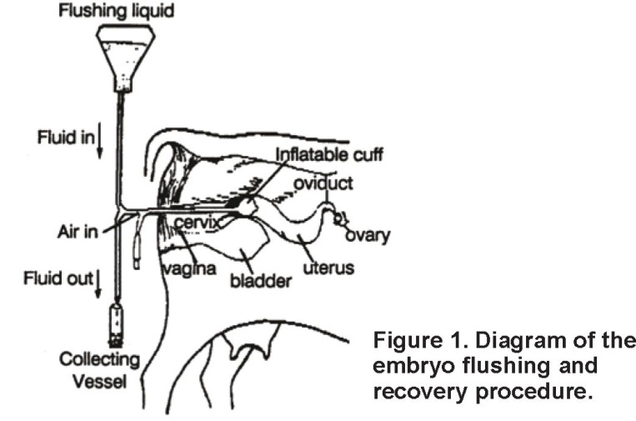

5)Evaluation of the Embryos
As the individual embryos are located using a microscope, they are evaluated for their quality and classified numerically as to the potential likelihood of success if transferred to a recipient female. Embryos are classified according to these subjective criteria as:
Grade 1: Excellent or good Grade 2: Fair Grade 3: Poor Grade 4: Dead or degenerating

6)Selection and Preparation of Recipient Females
Proper recipient herd management is critical to embryo transfer success. Cows that are reproductively sound, that exhibit calving ease and that have good milking and mothering ability are recipient prospects.
They must be on a proper plane of nutrition (body condition score 6 for beef cows and dairy body condition score 3 to 4). These cows also must be on a sound herd health program. To maximize embryo survival in the recipient female following transfer, conditions in the recipient reproductive tract should closely resemble those in the donor. This requires synchronization of the estrous cycles between the donor and the recipients, optimally within one day of each other. Synchronization of the recipients can be done in a similar manner and at the same working time as the donor cows. There are a number of different estrous synchronization protocols with advantages and disadvantages for each protocol. The critical point regarding recipient cow estrous synchronization is the timing must match the time of insemination of the donor cow so that the donor and the recipients have a similar uterine environment seven days later when the transfer takes place.

7)Transfer of the Embryos
The transfer of the embryo into the recipient cow first requires “loading” the embryo into a 1/4-mL insemination straw. This is done under microscopic viewing with the aid of a 1-mL syringe and requires considerable practice, patience and dexterity. Degenerated embryos or embryos of very low grade need not be loaded and can be discarded. Just prior to embryo transfer, the ovaries of the recipient are palpated rec-tally to determine which ovary has ovulated. With the aid of an assistant to hold open the vulva of the recipient cow, the transfer gun or insemination rod is carefully passed through the cervix. The tip of the rod is then allowed to slide into the horn on the same side of the ovary with an active corpus luteum.

8)Expected Embryo Transplant Results
Embryo production varies greatly from donor to donor and flush to flush. Average production is approximately six freezable (excellent and good) and eight transferable (excellent, good, fair and poor) embryos per superovulation.
Pregnancy rates vary from flush to flush with fresh averages 60 to 70 percent and frozen 50 to 60 percent. Many factors affect pregnancy rates such as embryo quality, recipients, technical ability and donor. Some donors consistently produce embryos with higher pregnancy rates than others with embryos of similar grade. This last factor seems to be uncontrollable and unpredictable.

